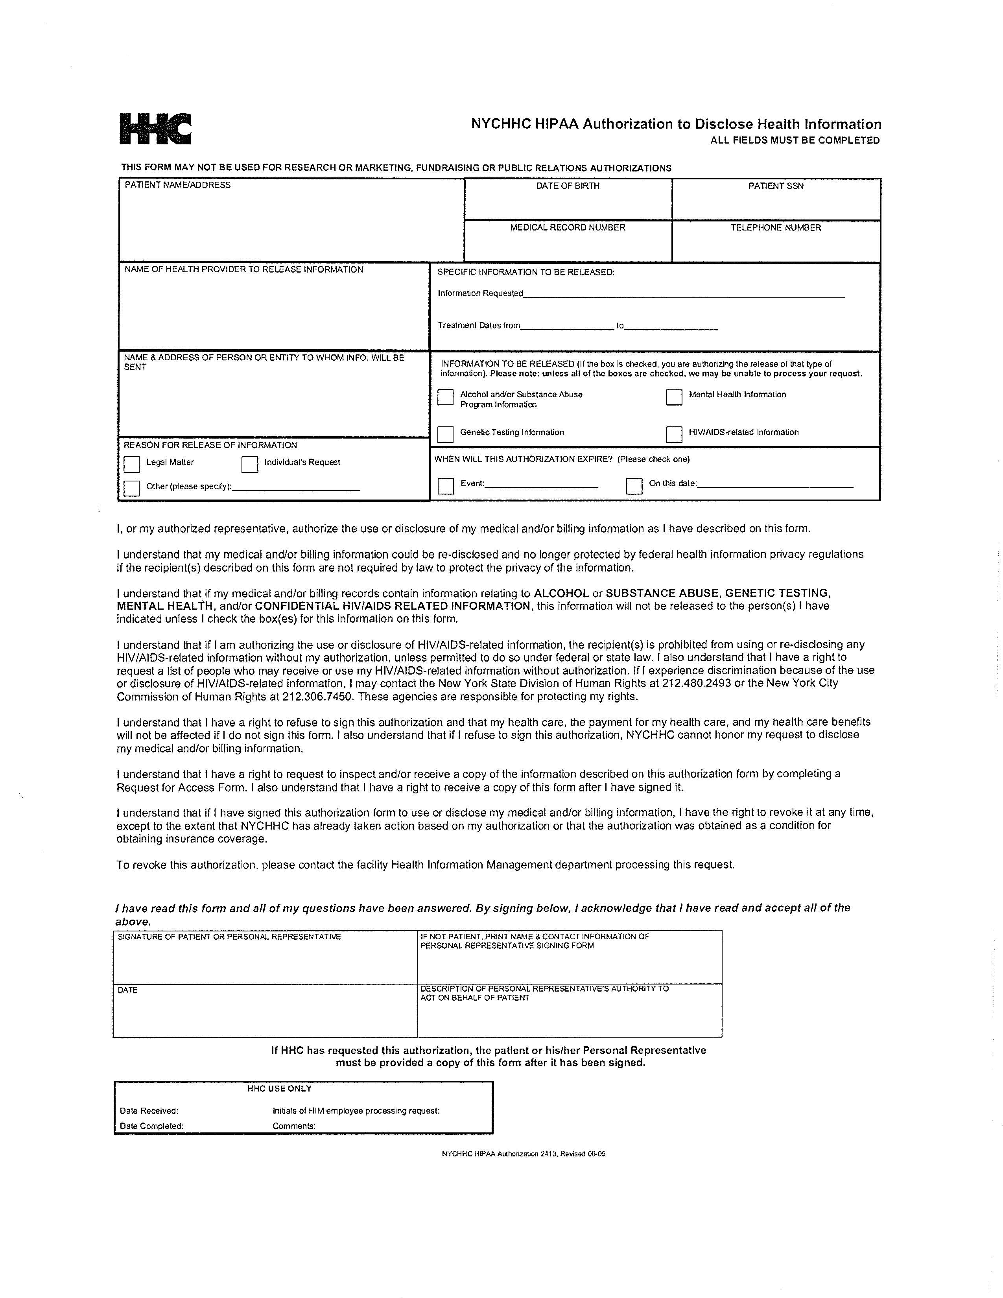

`
Order No. 01-26300 - 005
Joshy Kurian

,
04/22/1980
Glen Rodriguez, Esquire, McCarthy & Rodriguez, c/o Axiom Requisition Copy Service2869 Jolly Rd
Okemos, Michigan 48864

XXX-XX-0243
X

FROM 04/22/1980 TO PRESENT: Any and all MEDICAL RECORDS, including but not limited to patient history form(s), reports, etc. pertaining to Joshy Kurian SSN: XXX-XX-0243, DOB: 04/22/1980.

City Hospital Center at Elmhurst a/k/a Elmhurst Hospital Center

